- Why do you need to scale your data for the k-NN algorithm?
- Is Euclidean Distance always the case?
- Why should we not use the KNN algorithm for large datasets?

Can the KNN algorithm be used for regression problem statements?

How can you relate KNN Algorithm to the Bias-Variance tradeoff?

What are the things which should be kept in our mind while choosing the value of k in the KNN Algorithm?

Is it possible to use the KNN algorithm for Image processing?
- Why does the k-NN algorithm do more computation on test time rather than train time?
- Explain the working of KNN algorithm.
- Why do we need KNN-Algorithm?

Solutions:

- Imagine a dataset having m number of “examples” and n number of “features”. There is one feature dimension having values exactly between 0 and 1. Meanwhile, there is also a feature dimension that varies from -99999 to 99999. Considering the formula of Euclidean Distance, this will affect the performance by giving higher weightage to variables having a higher magnitude.
- Although Euclidean Distance is the most common method used and taught, it is not always the optimal decision. In fact, it is hard to come up with the right metric just by looking at data, so I would suggest trying a set of them. However, there are some special cases. For instance, hamming distance is used in case of a categorical variable.
- Here is an overview of the data flow that occurs in the KNN algorithm:
- Calculate the distances to all vectors in a training set and store them
- Sort the calculated distances
- Store the K nearest vectors
- Calculate the most frequent class displayed by K nearest vectors
Imagine you have a very large dataset. Therefore, it is not only a bad decision to store a large amount of data but it is also computationally costly to keep calculating and sorting all the values.
- Yes, KNN can be used for regression problem statements.
In other words, the KNN algorithm can be applied when the dependent variable is continuous. For regression problem statements, the predicted value is given by the average of the values of its k nearest neighbours.
- Problem with having too small K:
The major concern associated with small values of K lies behind the fact that the smaller value causes noise to have a higher influence on the result which will also lead to a large variance in the predictions.
Problem with having too large K:
The larger the value of K, the higher is the accuracy. If K is too large, then our model is under-fitted. As a result, the error will go up again. So, to prevent your model from under-fitting it should retain the generalization capabilities otherwise there are fair chances that your model may perform well in the training data but drastically fail in the real data. The computational expense of the algorithm also increases if we choose the k very large.
So, choosing k to a large value may lead to a model with a large bias(error).
The effects of k values on the bias and variance is explained below :
- As the value of k increases, the bias will be increases
- As the value of k decreases, the variance will increases
- With the increasing value of K, the boundary becomes smoother
So, there is a tradeoff between overfitting and underfitting and you have to maintain a balance while choosing the value of K in KNN. Therefore, K should not be too small or too large.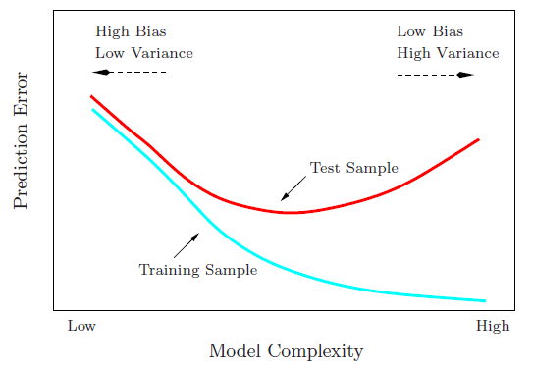

- If K is small, then results might not be reliable because the noise will have a higher influence on the result. If K is large, then there will be a lot of processing to be done which may adversely impact the performance of the algorithm.
So, the following things must be considered while choosing the value of K:
- K should be the square root of n (number of data points in the training dataset).
- K should be chosen as the odd so that there are no ties. If the square root is even, then add or subtract 1 to it.
- Yes, KNN can be used for image processing by converting a 3-dimensional image into a single-dimensional vector and then using it as the input to the KNN algorithm.
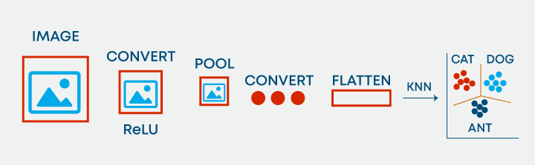
- That is absolutely true. The idea of the kNN algorithm is to find a k-long list of samples that are close to a sample we want to classify. Therefore, the training phase is basically storing a training set, whereas during the prediction stage the algorithm looks for k-neighbours using that stored data.

Working of KNN Algorithm
K-nearest neighbors (KNN) algorithm uses ‘feature similarity’ to predict the values of new datapoints which further means that the new data point will be assigned a value based on how closely it matches the points in the training set. We can understand its working with the help of following steps −
Step 1 − For implementing any algorithm, we need dataset. So during the first step of KNN, we must load the training as well as test data.
Step 2 − Next, we need to choose the value of K i.e. the nearest data points. K can be any integer.
Step 3 − For each point in the test data do the following −
- 3.1 − Calculate the distance between test data and each row of training data with the help of any of the methods, namely: Euclidean, Manhattan or Hamming distance. The most commonly used method to calculate distance is Euclidean.
- 3.2 − Now, based on the distance value, sort them in ascending order.
- 3.3 − Next, it will choose the top K rows from the sorted array.
- 3.4 − Now, it will assign a class to the test point based on most frequent class of these rows.
Step 4 − End
- Suppose there are two categories, i.e., Category A and Category B, and we have a new data point x1, so this data point will lie in which of these categories. To solve this type of problem, we need a K-NN algorithm. With the help of K-NN, we can easily identify the category or class of a particular dataset. Consider the below diagram:
